SVN Document

Login with user credentials

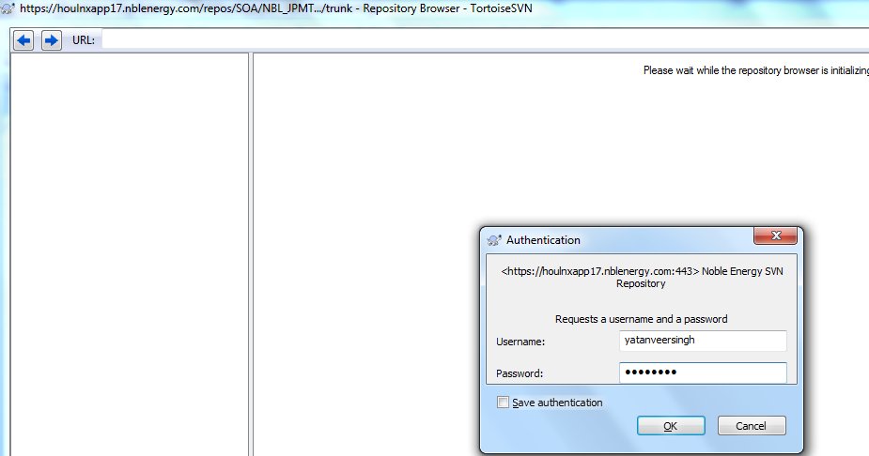

Create a simple project in your local folder to place it in SVN.

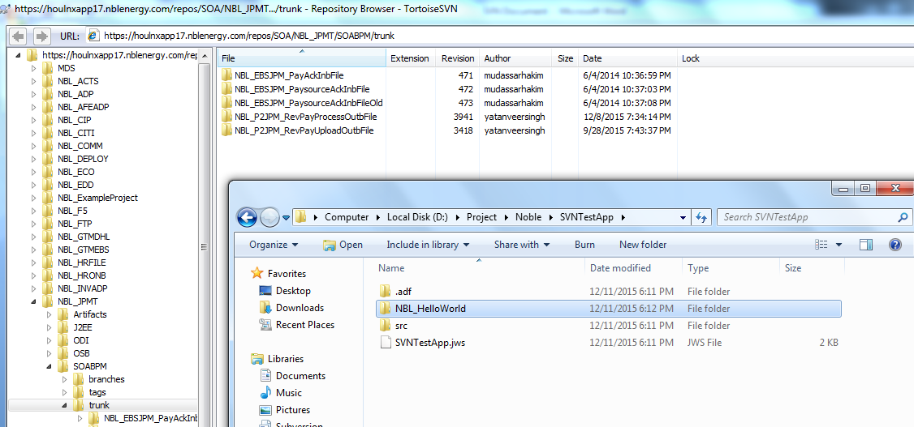

Move the project to SVN location by just dragging and dropping the project to the SVN location.

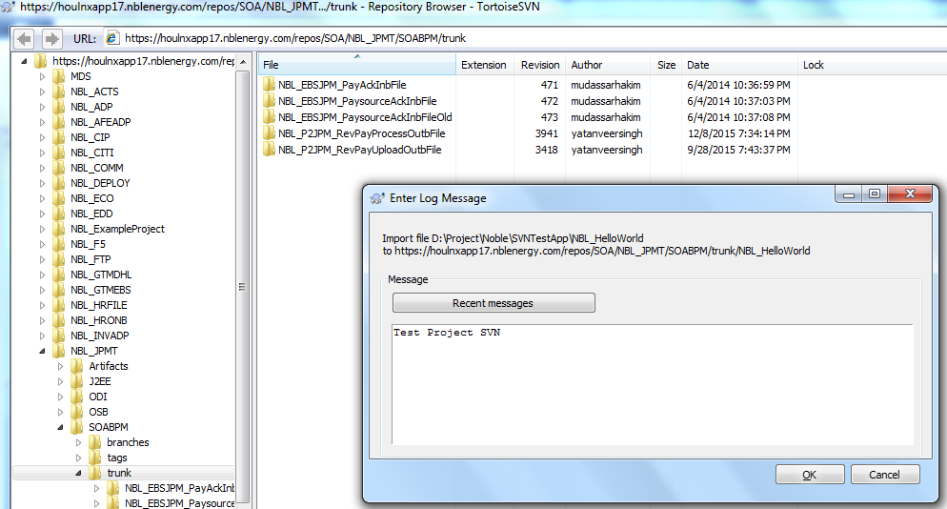

If we want to do changes to the project which is already in the SVN location, Select the project and right click and select checkout

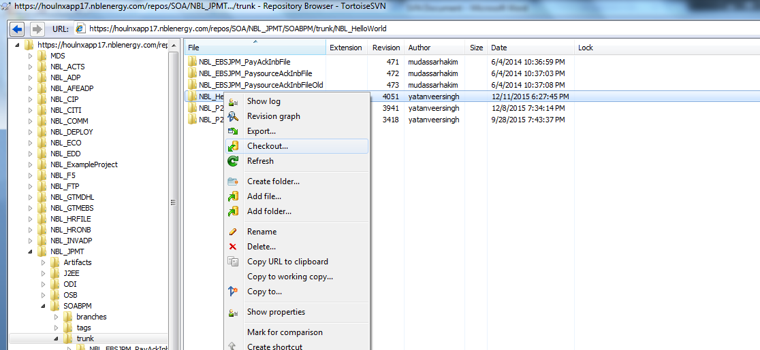

It will ask for a location to checkout in checkout directory, specify the location in your local directory,

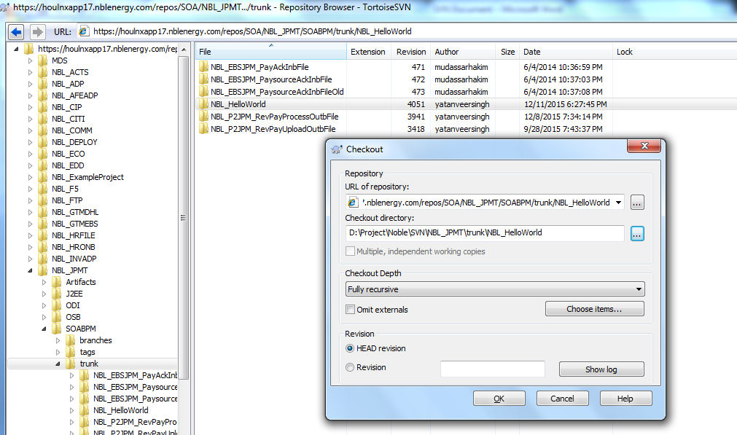

Checkout process finishes by showing the message as completed.

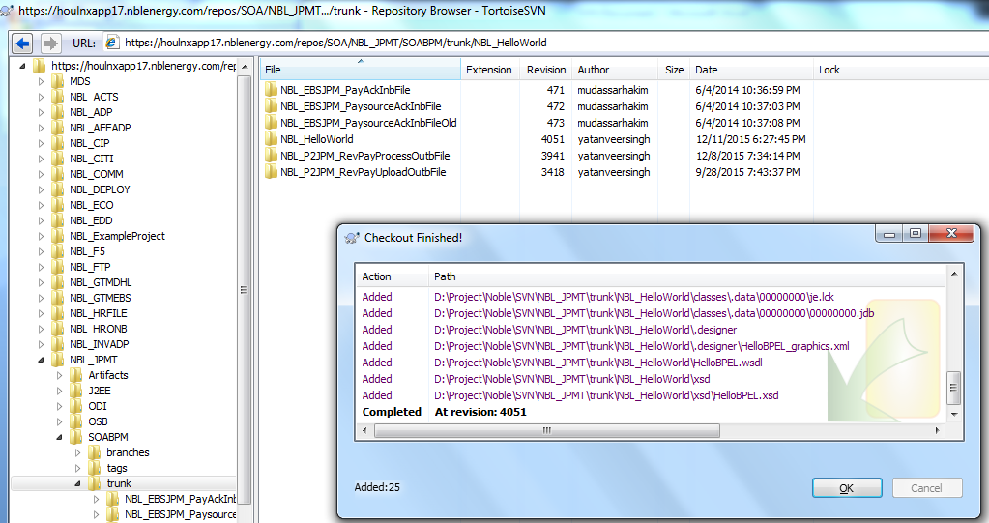

Go to the folder that we had mentioned in checkout and move that folder to a new location, here we can see the green tick mark to the files which indicates that the same files are there in SVN directory.

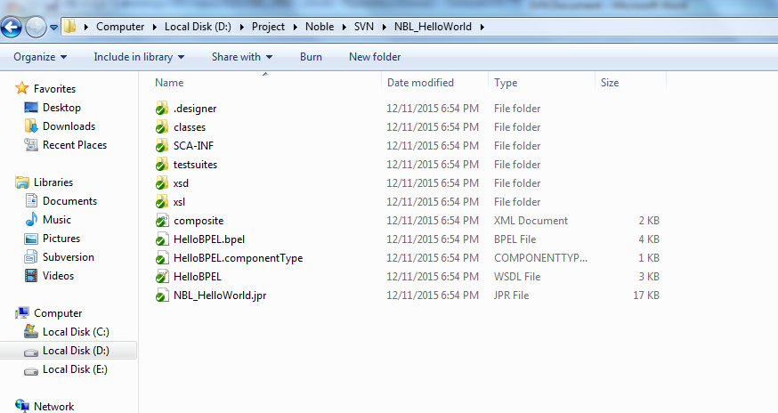

Open the project in Jdeveloper and do the changes that are required

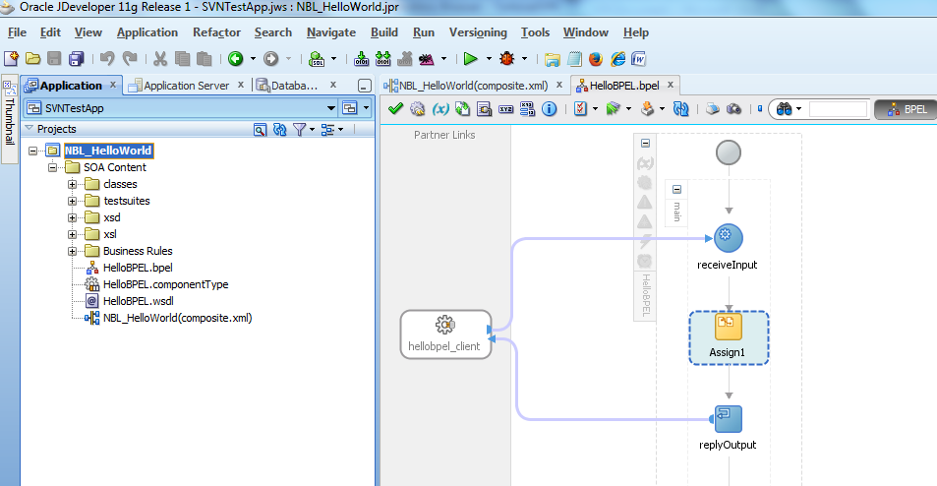

Once the changes are done you can move the folder back to the repository checkout directory, here we can see the files that are in red mark (Files in redmark indicates that those are changed files)

Note: We need to build a jar file for updating the latest jar.

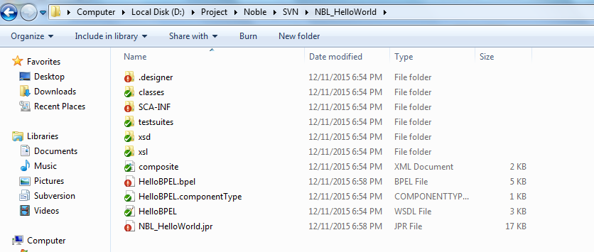

Cleanup the directory to clear unwanted data

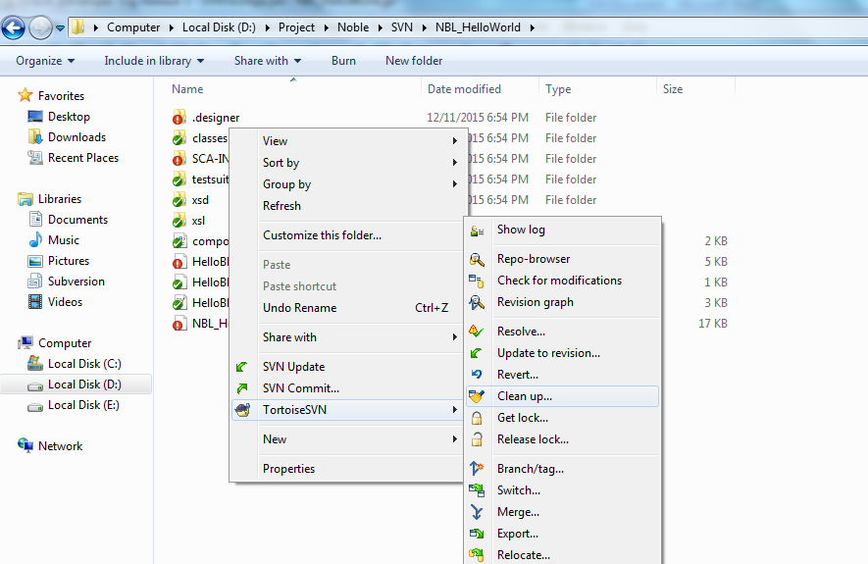

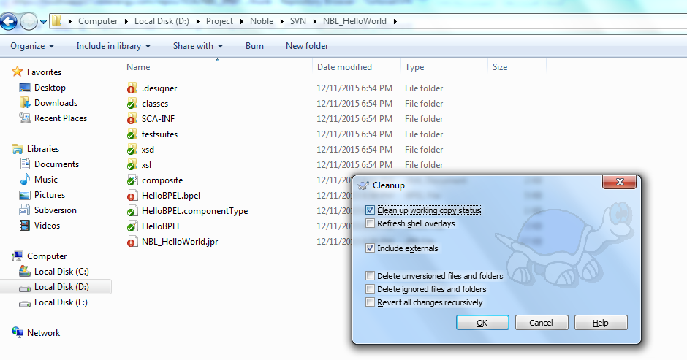

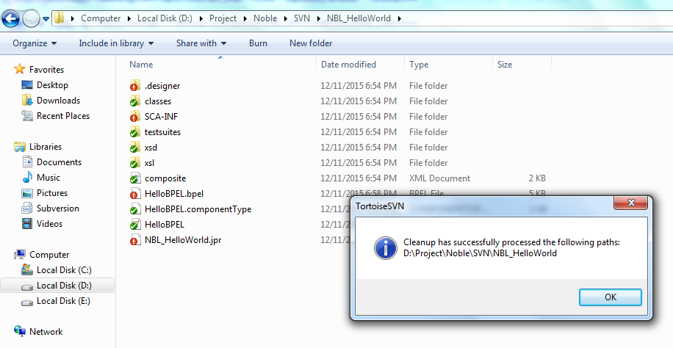

We need to add a new jar file under deploy folder which has updated changes

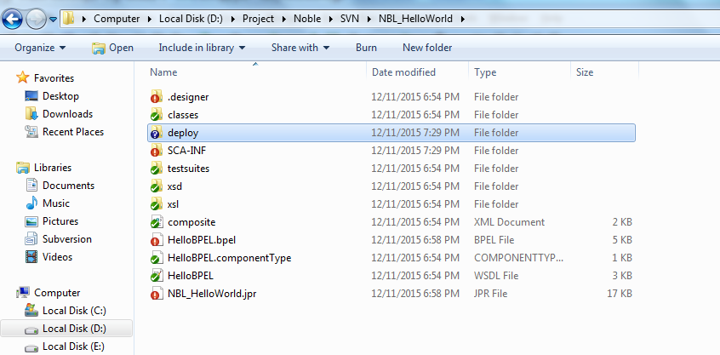

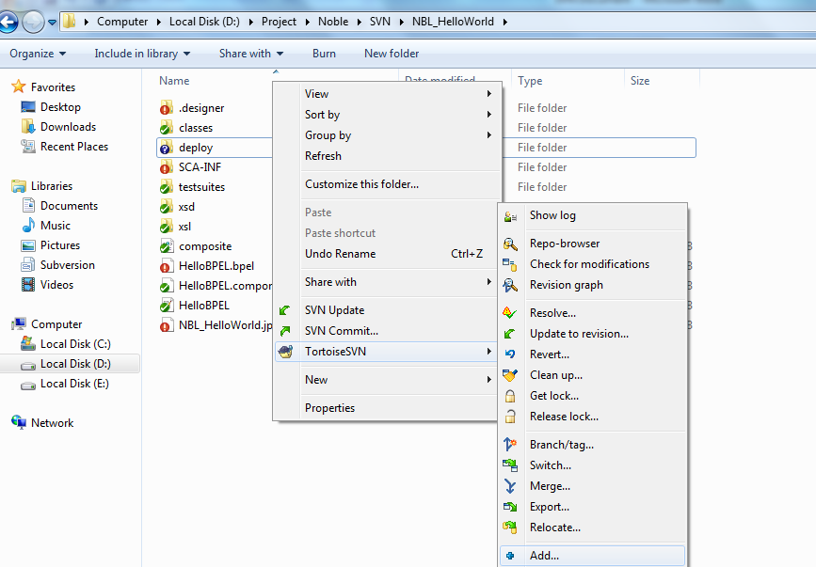

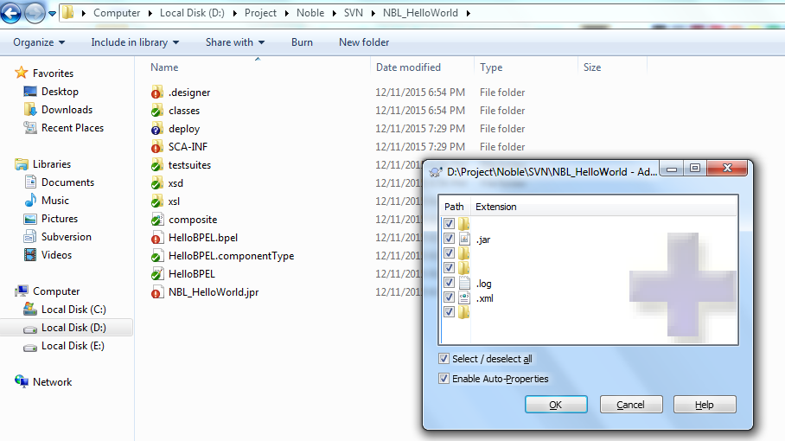

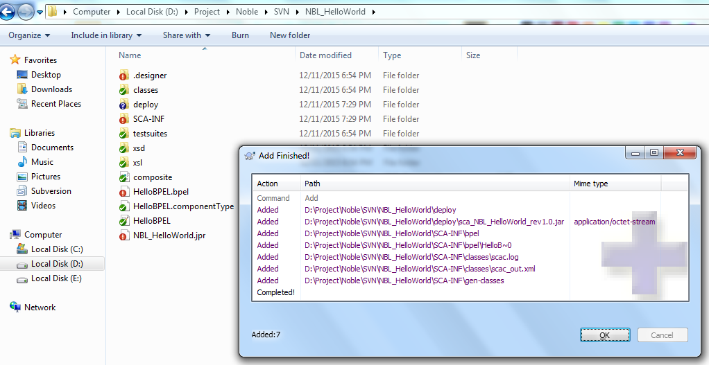

Folder shows a + sign stating that new jar file is addded

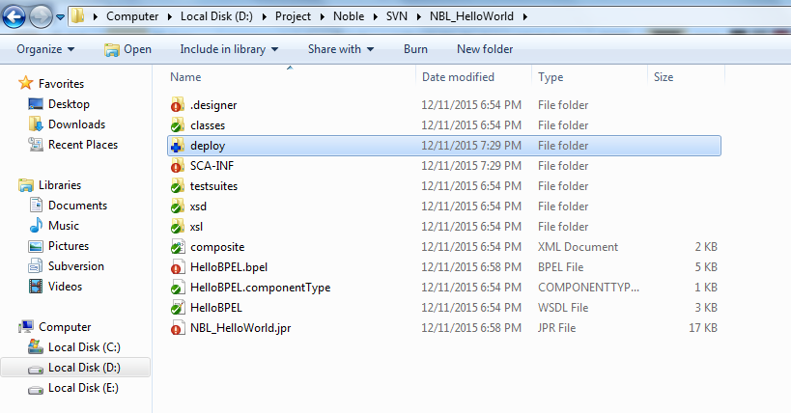

We should commit this code back into SVN by Right click and select and select SVN commit

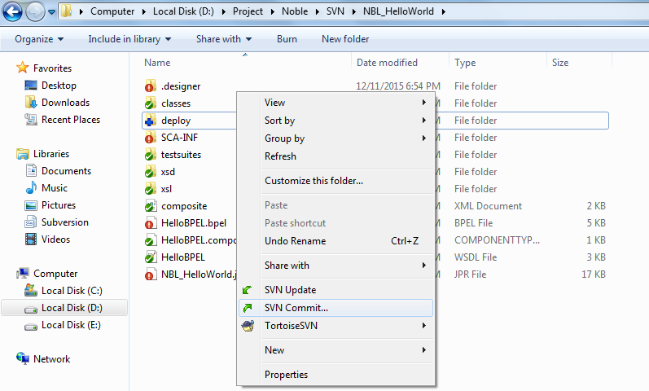

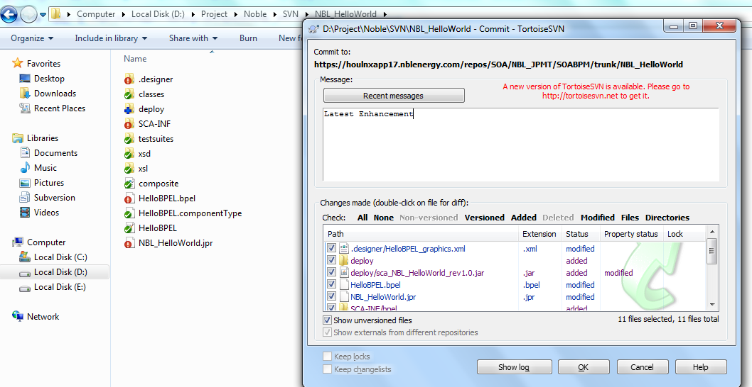

Once the changes are done it show the status as completed and we can see the green tick mark for all folders in the directory

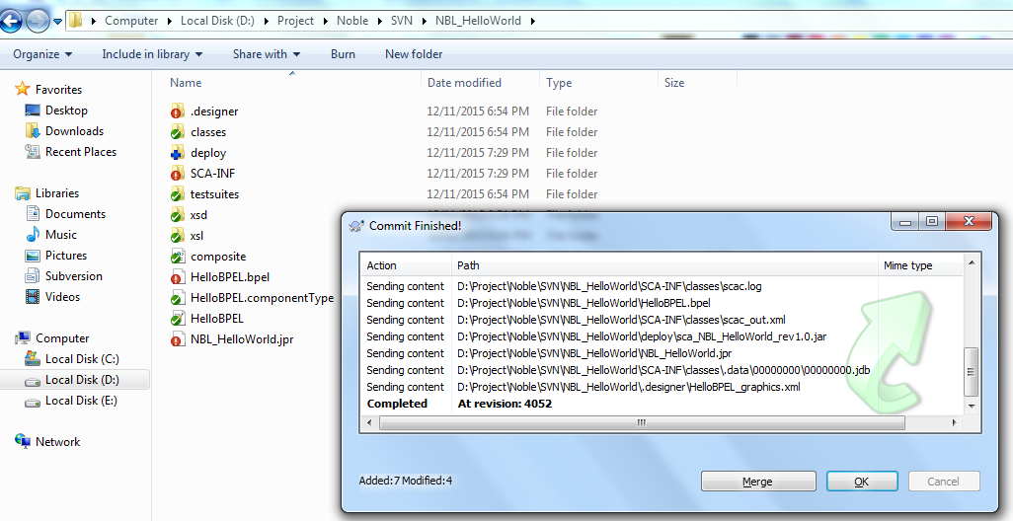

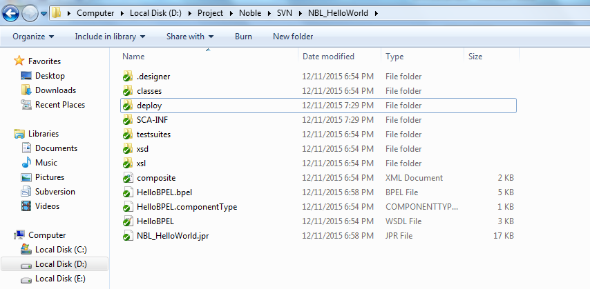

Change of date for the composite can be seen in SVN location and if we go inside the composite folder we can see the changes for the appropriate components.

